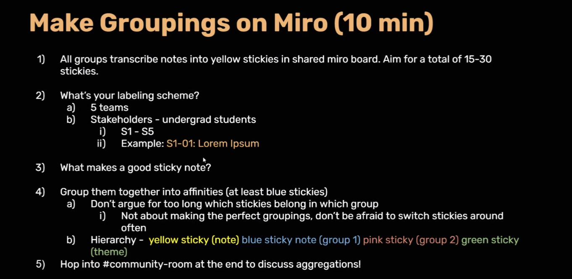

Interviewer: Philena

Interviewee: Hannah

Notes:

1. Ham and Swiss (cheese??) croissant (Unsure on specific name)
2. More of snack than meal
3. Starbucks
4. Not filling
5. Not much time to cook b/c of other tasks
6. Would buy again
7. Tasted good
8. 12pm (6 hr ago)
9. Ate at dorm
10. Line wasn’t long but wait was long after ordering
11. Ordered drink also, Very Berry drink, Venti size
12. Had to wait longer for sandwich bc they made a mistake
13. Gave drink and they forgot about sandwich
14. Didn’t want to spend money at a different restaurant/place
15. Starbs was the most convenient place to order food, got it at village because close
16. Had money in starbucks app
17. Caffeine was offered also at restaurant